Lab – Configuring a Point-to-Point GRE VPN Tunnel
- Topology
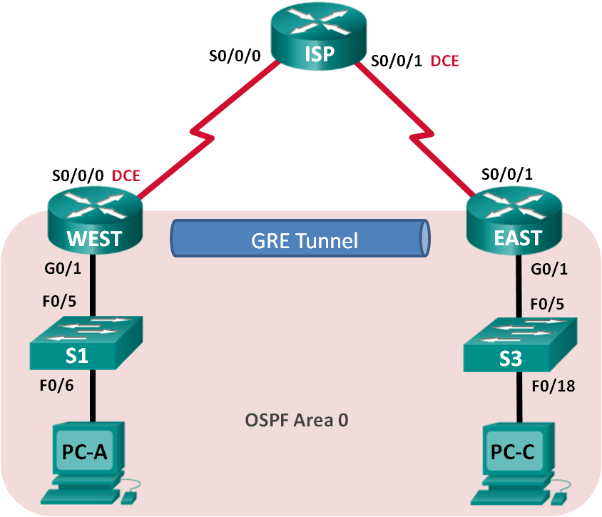
- Addressing Table
Device | Interface | IP Address | Subnet Mask | Default Gateway
WEST | G0/1 | 172.16.1.1 | 255.255.255.0 | N/A
 | S0/0/0 (DCE) | 10.1.1.1 | 255.255.255.252 | N/A
 | Tunnel0 | 172.16.12.1 | 255.255.255.252 | N/A
ISP | S0/0/0 | 10.1.1.2 | 255.255.255.252 | N/A
 | S0/0/1 (DCE) | 10.2.2.2 | 255.255.255.252 | N/A
EAST | G0/1 | 172.16.2.1 | 255.255.255.0 | N/A
 | S0/0/1 | 10.2.2.1 | 255.255.255.252 | N/A
 | Tunnel0 | 172.16.12.2 | 255.255.255.252 | N/A
PC-A | NIC | 172.16.1.3 | 255.255.255.0 | 172.16.1.1
PC-C | NIC | 172.16.2.3 | 255.255.255.0 | 172.16.2.1
- Objectives
Part 1: Configure Basic Device Settings
Part 2: Configure a GRE Tunnel
Part 3: Enable Routing over the GRE Tunnel
- Background / Scenario
Generic Routing Encapsulation (GRE) is a tunneling protocol that can encapsulate a variety of network layer protocols between two locations over a public network, such as the Internet.
GRE can be used with:
  - Connecting IPv6 networks over IPv4 networks
  - Multicast packets, such as OSPF, EIGRP, and streaming applications
In this lab, you will configure an unencrypted point-to-point GRE VPN tunnel and verify that network traffic is using the tunnel. You will also configure the OSPF routing protocol inside the GRE VPN tunnel. The GRE tunnel is between the WEST and EAST routers in OSPF area 0. The ISP has no knowledge of the GRE tunnel. Communication between the WEST and EAST routers and the ISP is accomplished using default static routes.
Note: The routers used with CCNA hands-on labs are Cisco 1941 Integrated Services Routers (ISRs) with Cisco IOS Release 15.2(4)M3 (universalk9 image). The switches used are Cisco Catalyst 2960s with Cisco IOS Release 15.0(2) (lanbasek9 image). Other routers, switches, and Cisco IOS versions can be used. Depending on the model and Cisco IOS version, the commands available and output produced might vary from what is shown in the labs. Refer to the Router Interface Summary Table at the end of this lab for the correct interface identifiers.
Note: Make sure that the routers and switches have been erased and have no startup configurations. If you are unsure, contact your instructor.
- Required Resources
- 3 Routers (Cisco 1941 with Cisco IOS Release 15.2(4)M3 universal image or comparable)
- 2 Switches (Cisco 2960 with Cisco IOS Release 15.0(2) lanbasek9 image or comparable)
- 2 PCs (Windows 7, Vista, or XP with terminal emulation program, such as Tera Term)
- Console cables to configure the Cisco IOS devices via the console ports
- Ethernet and serial cables as shown in the topology
- Configure Basic Device Settings
In Part 1, you will set up the network topology and configure basic router settings, such as the interface IP addresses, routing, device access, and passwords.
  - Cable the network as shown in the topology.
  - Initialize and reload the routers and switches.
  - Configure basic settings for each router.
    - Disable DNS lookup.
no ip domain-lookup
    - Configure the device names.
    - Encrypt plain text passwords.
    - Create a message of the day (MOTD) banner warning users that unauthorized access is prohibited.
    - Assign class as the encrypted privileged EXEC mode password.
    - Assign cisco as the console and vty password and enable login.
    - Set console logging to synchronous mode.
    - Apply IP addresses to Serial and Gigabit Ethernet interfaces according to the Addressing Table and activate the physical interfaces. Do NOT configure the Tunnel0 interfaces at this time.
    - Set the clock rate to 128000 for DCE serial interfaces.
  - Configure default routes to the ISP router.
WEST(config)# ip route 0.0.0.0 0.0.0.0 10.1.1.2

EAST(config)# ip route 0.0.0.0 0.0.0.0 10.2.2.2
  - Configure the PCs.
Assign IP addresses and default gateways to the PCs according to the Addressing Table.
  - Verify connectivity.
At this point, the PCs are unable to ping each other. Each PC should be able to ping its default gateway. The routers are able to ping the serial interfaces of the other routers in the topology. If not, troubleshoot until you can verify connectivity.
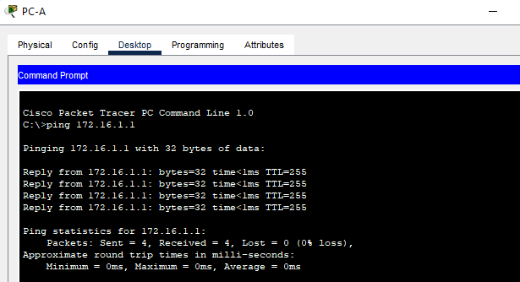
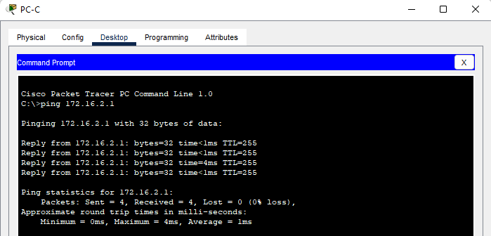
  - Save your running configuration.
- Configure a GRE Tunnel
In Part 2, you will configure a GRE tunnel between the WEST and EAST routers.
  - Configure the GRE tunnel interface.
    - Configure the tunnel interface on the WEST router. Use S0/0/0 on WEST as the tunnel source interface and 10.2.2.1 as the tunnel destination on the EAST router.
WEST(config)# interface tunnel 0
WEST(config-if)# ip address 172.16.12.1 255.255.255.252
WEST(config-if)# tunnel source s0/0/0
WEST(config-if)# tunnel destination 10.2.2.1
    - Configure the tunnel interface on the EAST router. Use S0/0/1 on EAST as the tunnel source interface and 10.1.1.1 as the tunnel destination on the WEST router.
EAST(config)# interface tunnel 0
EAST(config-if)# ip address 172.16.12.2 255.255.255.252
EAST(config-if)# tunnel source 10.2.2.1
EAST(config-if)# tunnel destination 10.1.1.1
Note: For the tunnel source command, either the interface name or the IP address can be used as the source.
  - Verify that the GRE tunnel is functional.
    - Verify the status of the tunnel interface on the WEST and EAST routers.
WEST# show ip interface brief
Interface IP-Address OK? Method Status Protocol
Embedded-Service-Engine0/0 unassigned YES unset administratively down down
GigabitEthernet0/0 unassigned YES unset administratively down down
GigabitEthernet0/1 172.16.1.1 YES manual up up
Serial0/0/0 10.1.1.1 YES manual up up
Serial0/0/1 unassigned YES unset administratively down down
Tunnel0 172.16.12.1 YES manual up up

EAST# show ip interface brief
Interface IP-Address OK? Method Status Protocol
Embedded-Service-Engine0/0 unassigned YES unset administratively down down
GigabitEthernet0/0 unassigned YES unset administratively down down
GigabitEthernet0/1 172.16.2.1 YES manual up up
Serial0/0/0 unassigned YES unset administratively down down
Serial0/0/1 10.2.2.1 YES manual up up
Tunnel0 172.16.12.2 YES manual up up
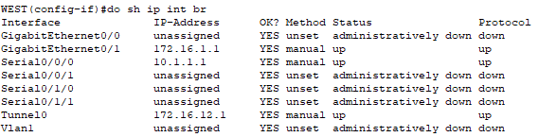
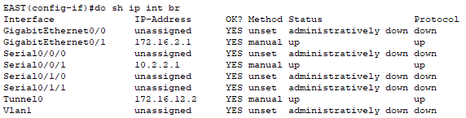

    - Issue the show interfaces tunnel 0 command to verify the tunneling protocol, tunnel source, and tunnel destination used in this tunnel.
What is the tunneling protocol used? What are the tunnel source and destination IP addresses associated with GRE tunnel on each router?
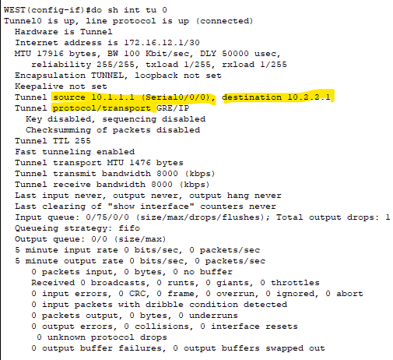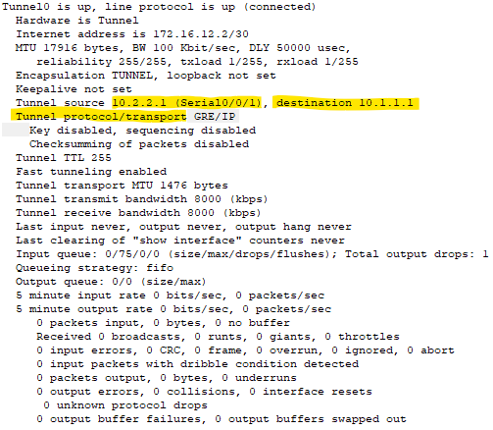____________________________________________________________________________________
    - Ping across the tunnel from the WEST router to the EAST router using the IP address of the tunnel interface.
WEST# ping 172.16.12.2
Type escape sequence to abort.
Sending 5, 100-byte ICMP Echos to 172.16.12.2, timeout is 2 seconds:
!!!!!
Success rate is 100 percent (5/5), round-trip min/avg/max = 32/34/36 ms
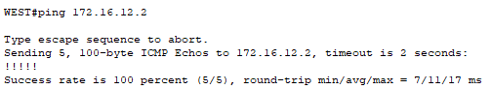
    - Use the traceroute command on the WEST to determine the path to the tunnel interface on the EAST router. What is the path to the EAST router?
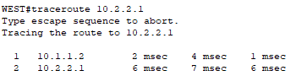

path: 10.1.1.2 -> 10.2.2.1
________________________________________________________________________
    - Ping and trace the route across the tunnel from the EAST router to the WEST router using the IP address of the tunnel interface.
What is the path to the WEST router from the EAST router?
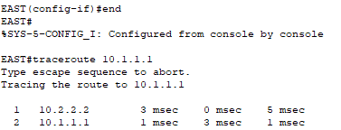
Path: 10.2.2.2 -> 10.1.1.1
____________________________________
With which interfaces are these IP addresses associated? Why?
10.2.2.1 -> EAST interface s0/0/1
10.1.1.1 -> WEST interface s0/0/0
10.1.1.2 & 10.2.2.2 -> ISP interface
____________________________________________________________________________________
    - The ping and traceroute commands should be successful. If not, troubleshoot before continuing to the next part.
- Enable Routing over the GRE Tunnel
In Part 3, you will configure OSPF routing so that the LANs on the WEST and EAST routers can communicate using the GRE tunnel.
After the GRE tunnel is set up, the routing protocol can be implemented. For GRE tunneling, a network statement will include the IP network of the tunnel, instead of the network associated with the serial interface. just like you would with other interfaces, such as Serial and Ethernet. Remember that the ISP router is not participating in this routing process.
  - Configure OSPF routing for area 0 over the tunnel.
    - Configure OSPF process ID 1 using area 0 on the WEST router for the 172.16.1.0/24 and 172.16.12.0/24 networks.X
WEST(config)# router ospf 1
WEST(config-router)# network 172.16.1.0 0.0.0.255 area 0
WEST(config-router)# network 172.16.12.0 0.0.0.3 area 0
    - Configure OSPF process ID 1 using area 0 on the EAST router for the 172.16.2.0/24 and 172.16.12.0/24 networks.
EAST(config)# router ospf 1
EAST(config-router)# network 172.16.2.0 0.0.0.255 area 0
EAST(config-router)# network 172.16.12.0 0.0.0.3 area 0
  - Verify OSPF routing.
    - From the WEST router, issue the show ip route command to verify the route to 172.16.2.0/24 LAN on the EAST router.
WEST# show ip route
Codes: L - local, C - connected, S - static, R - RIP, M - mobile, B - BGP
D - EIGRP, EX - EIGRP external, O - OSPF, IA - OSPF inter area
N1 - OSPF NSSA external type 1, N2 - OSPF NSSA external type 2
E1 - OSPF external type 1, E2 - OSPF external type 2
i - IS-IS, su - IS-IS summary, L1 - IS-IS level-1, L2 - IS-IS level-2
ia - IS-IS inter area, * - candidate default, U - per-user static route
o - ODR, P - periodic downloaded static route, H - NHRP, l - LISP
+ - replicated route, % - next hop override

Gateway of last resort is 10.1.1.2 to network 0.0.0.0

S* 0.0.0.0/0 [1/0] via 10.1.1.2
10.0.0.0/8 is variably subnetted, 2 subnets, 2 masks
C 10.1.1.0/30 is directly connected, Serial0/0/0
L 10.1.1.1/32 is directly connected, Serial0/0/0
172.16.0.0/16 is variably subnetted, 5 subnets, 3 masks
C 172.16.1.0/24 is directly connected, GigabitEthernet0/1
L 172.16.1.1/32 is directly connected, GigabitEthernet0/1
O 172.16.2.0/24 [110/1001] via 172.16.12.2, 00:00:07, Tunnel0
C 172.16.12.0/30 is directly connected, Tunnel0
L 172.16.12.1/32 is directly connected, Tunnel0
What is the exit interface and IP address to reach the 172.16.2.0/24 network?
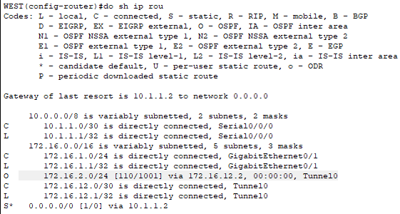
IP address: 172.16.12.2, interface: tunnel0
____________________________________________________________________________________
    - From the EAST router issue the command to verify the route to 172.16.1.0/24 LAN on the WEST router.
What is the exit interface and IP address to reach the 172.16.1.0/24 network?
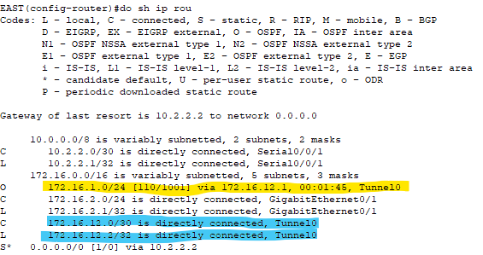
IP address: 172.16.12.1, interface: tunnel0
____________________________________________________________________________________
  - Verify end-to-end connectivity.
    - Ping from PC-A to PC-C. It should be successful. If not, troubleshoot until you have end-to-end connectivity.
Note: It may be necessary to disable the PC firewall to ping between PCs.
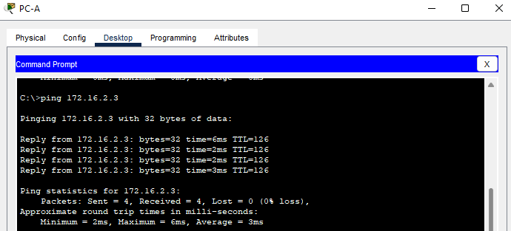
    - Traceroute from PC-A to PC-C. What is the path from PC-A to PC-C?
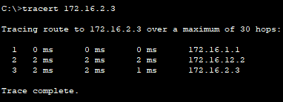
Path: 172.16.1.1 (PC A) -> 172.16.12.2 (Tunnel) -> 172.16.2.3 (PC B)
____________________________________________________________________________________
- Reflection
  - What other configurations are needed to create a secured GRE tunnel?
_______________________________________________________________________________________
  - If you added more LANs to the WEST or EAST router, what would you need to do so that the network will use the GRE tunnel for traffic?
Configure the new network to the routing protocol as the tunnel interface
_______________________________________________________________________________________
- Router Interface Summary Table
Router Interface Summary
Router Model | Ethernet Interface #1 | Ethernet Interface #2 | Serial Interface #1 | Serial Interface #2
1800 | Fast Ethernet 0/0 (F0/0) | Fast Ethernet 0/1 (F0/1) | Serial 0/0/0 (S0/0/0) | Serial 0/0/1 (S0/0/1)
1900 | Gigabit Ethernet 0/0 (G0/0) | Gigabit Ethernet 0/1 (G0/1) | Serial 0/0/0 (S0/0/0) | Serial 0/0/1 (S0/0/1)
2801 | Fast Ethernet 0/0 (F0/0) | Fast Ethernet 0/1 (F0/1) | Serial 0/1/0 (S0/1/0) | Serial 0/1/1 (S0/1/1)
2811 | Fast Ethernet 0/0 (F0/0) | Fast Ethernet 0/1 (F0/1) | Serial 0/0/0 (S0/0/0) | Serial 0/0/1 (S0/0/1)
2900 | Gigabit Ethernet 0/0 (G0/0) | Gigabit Ethernet 0/1 (G0/1) | Serial 0/0/0 (S0/0/0) | Serial 0/0/1 (S0/0/1)
Note: To find out how the router is configured, look at the interfaces to identify the type of router and how many interfaces the router has. There is no way to effectively list all the combinations of configurations for each router class. This table includes identifiers for the possible combinations of Ethernet and Serial interfaces in the device. The table does not include any other type of interface, even though a specific router may contain one. An example of this might be an ISDN BRI interface. The string in parenthesis is the legal abbreviation that can be used in Cisco IOS commands to represent the interface.

VPN
- Virtual Private Network
- Secure by encryption
- "hide IP" / fake IP
- [encapsulation & encryption] -> security
- VPN concept
  - encapsulate me, then encrypt the passenger protocol (me) then send

For current tunnel do in lap is just encapsulation, for encryption can explore sendiri

